**Prism Manual**

**Categorical Data Analysis**

Jingwen Gu

BCBB/OCICB/NIAID

This lab will introduce the methods of conducting categorical data analysis using examples from Categorical data analysis workshop in Prism. For more analysis for categorical data analysis in Prism, please check chapter in [Prism statistics guide](https://www.graphpad.com/guides/prism/7/statistics/index.htm?stat_interpreting_results_contingen_2.htm). To learn more about the examples and interpretation, please categorical data analysis lecture note provided by BCBB.

**0. Outline:**

1) Positive predictive value and Negative predictive value

2) Sensitivity, Specificity

3) Odds ratio

4) Relative risk

5) Perform statistical testing for contingency table

**1. Positive predictive value and Negative predictive value**

1.1 Copy the data 1 from Prism example.csv. Open Prism, Select **Contingency** under “New Table & Graph”; Select **Enter or import data into a new table**, then click **Create**.

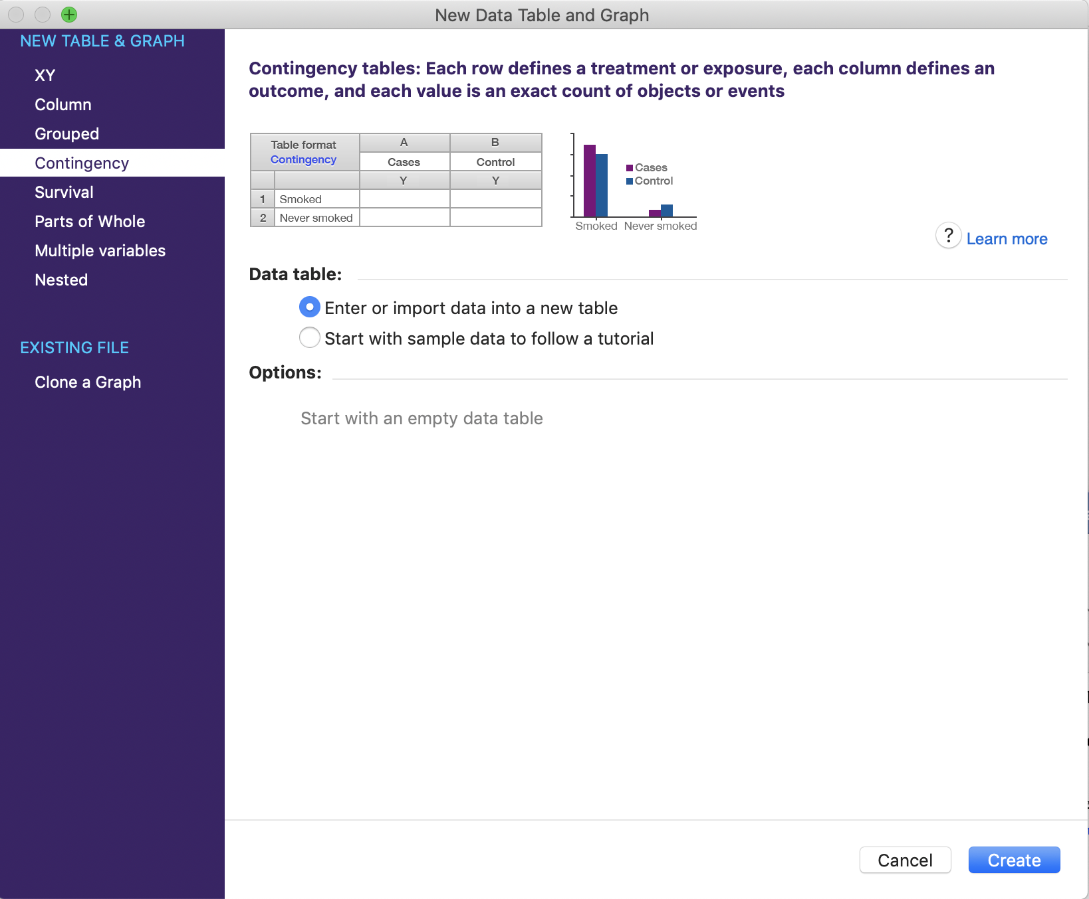

1.2 **Copy data 1** from “Prism examples.xlsx” into the blank sheet.

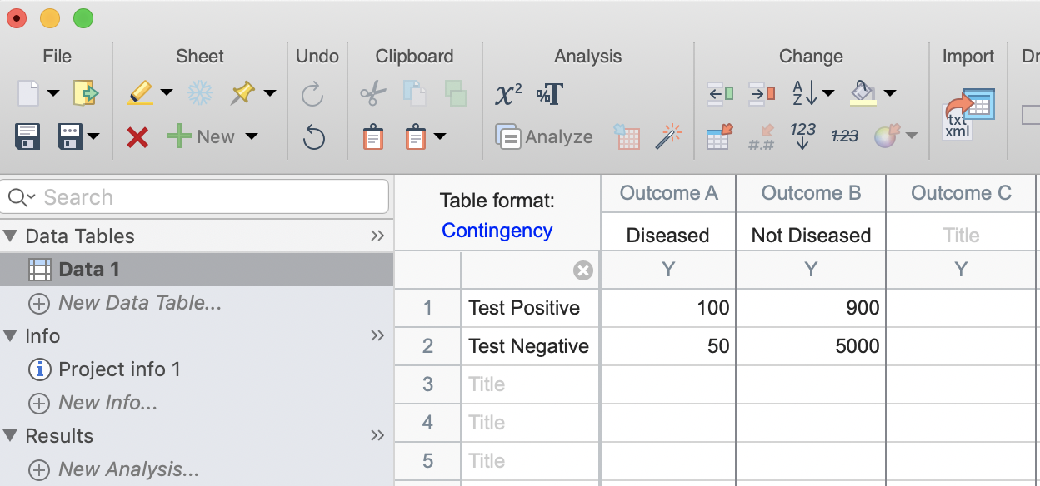

1.3 Click **Analyze ** then select **Chi-square (and Fisher’s exact) test** under Contingency table analyses list, then click **OK.**

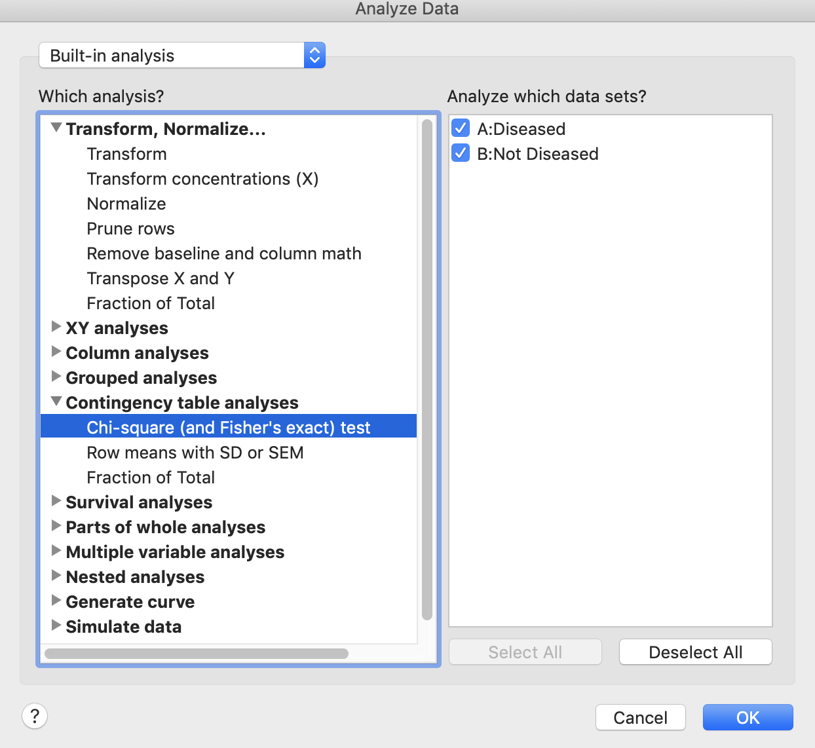

1.4 Check **Sensitivity, specificity and predictive values** under Main Calculations menu. Click **OK**.

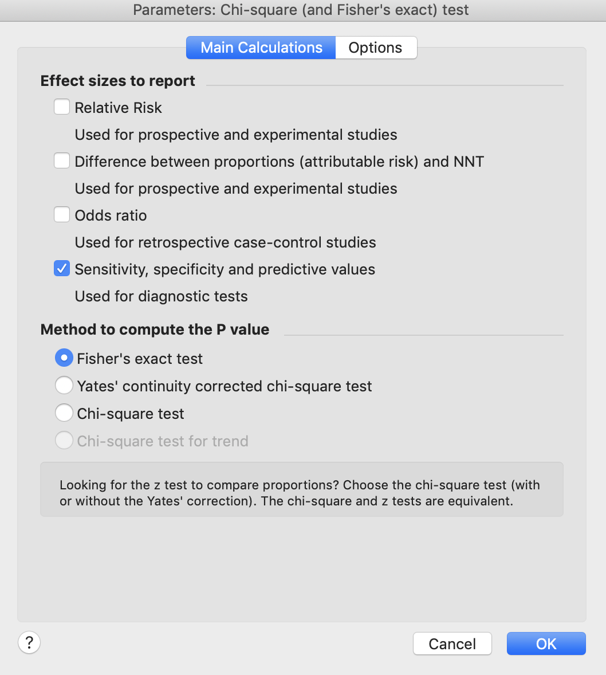

1.5 Prism will return the report with 95% confidence interval. They are circled in red below.

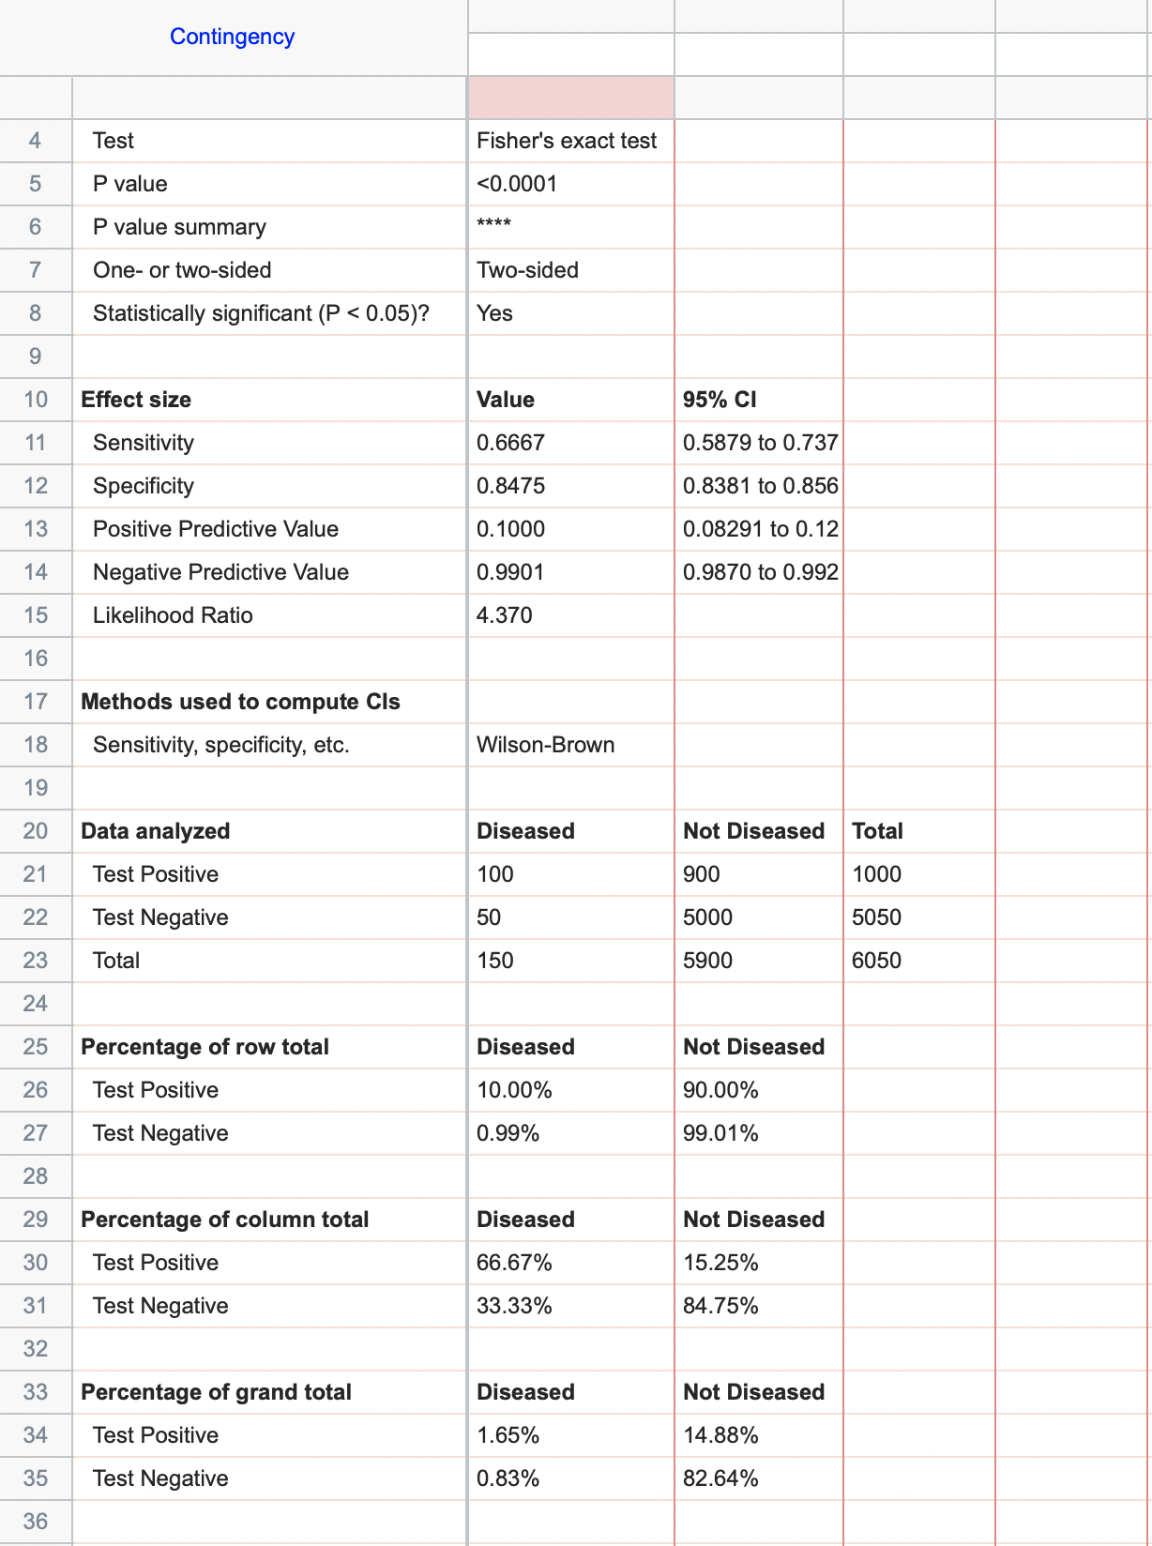

**2. Sensitivity, specificity**

2.1 Open a blank contingency sheet (see 1.1). **Copy data 2** from “Prism examples.xlsx”.

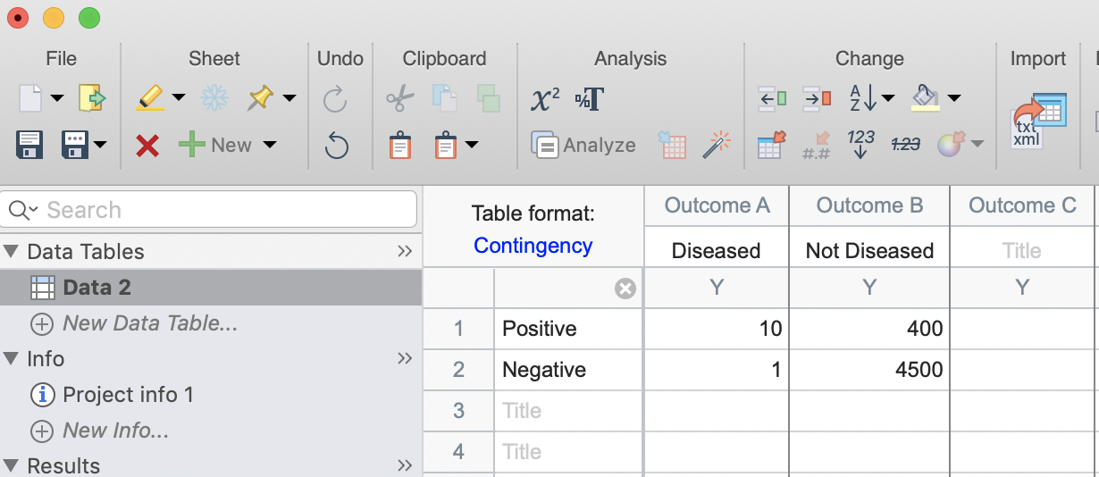

2.2 **Follow 1.3 and 1.4** (same way as calculating PPV and NPV). Prism will return result with 95% confidence interval.

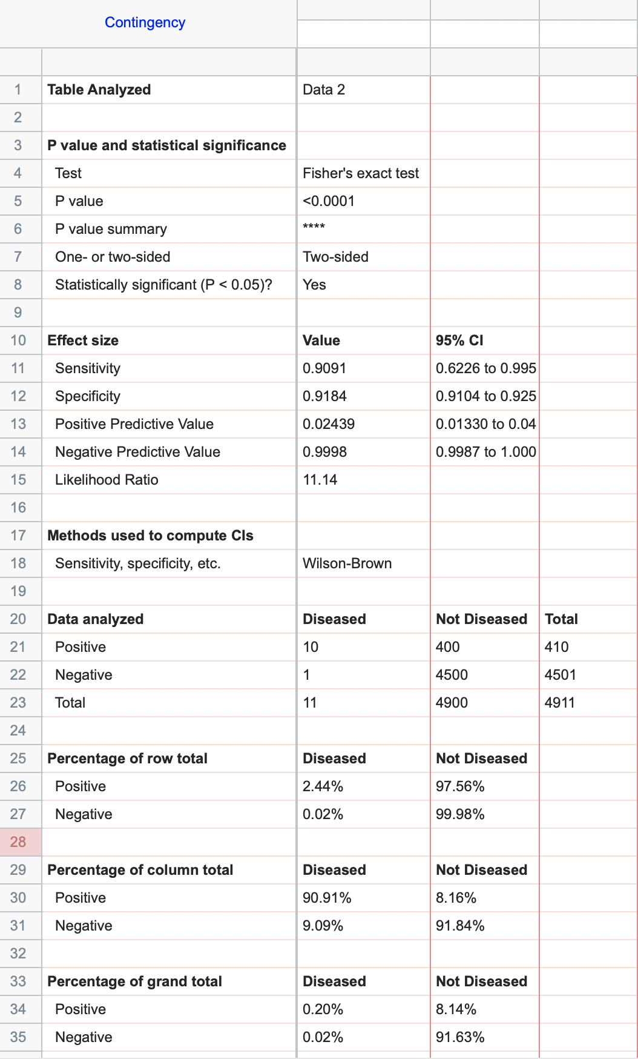

**3. Odds ratio**

3.1 Open a blank contingency sheet (see 1.1). **Copy data 3** from “Prism examples.xlsx”.

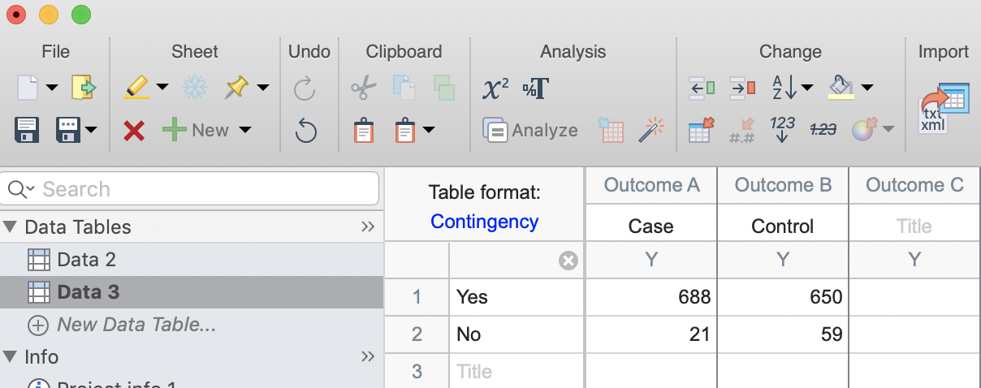

3.2 Click **Analyze,** select **Chi-square (and Fisher’s exact) test** under Contingency table analyses list, then click **OK.** Select **Odds ratio.** Then **OK**.

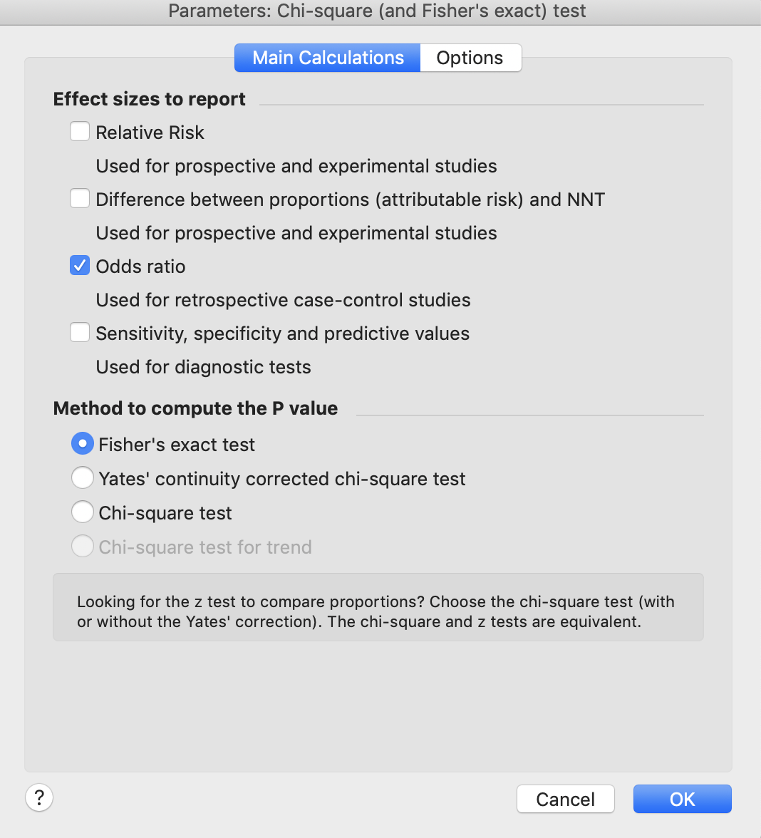

3.3 It will return result with 95% confidence interval. It is circled in Red below.

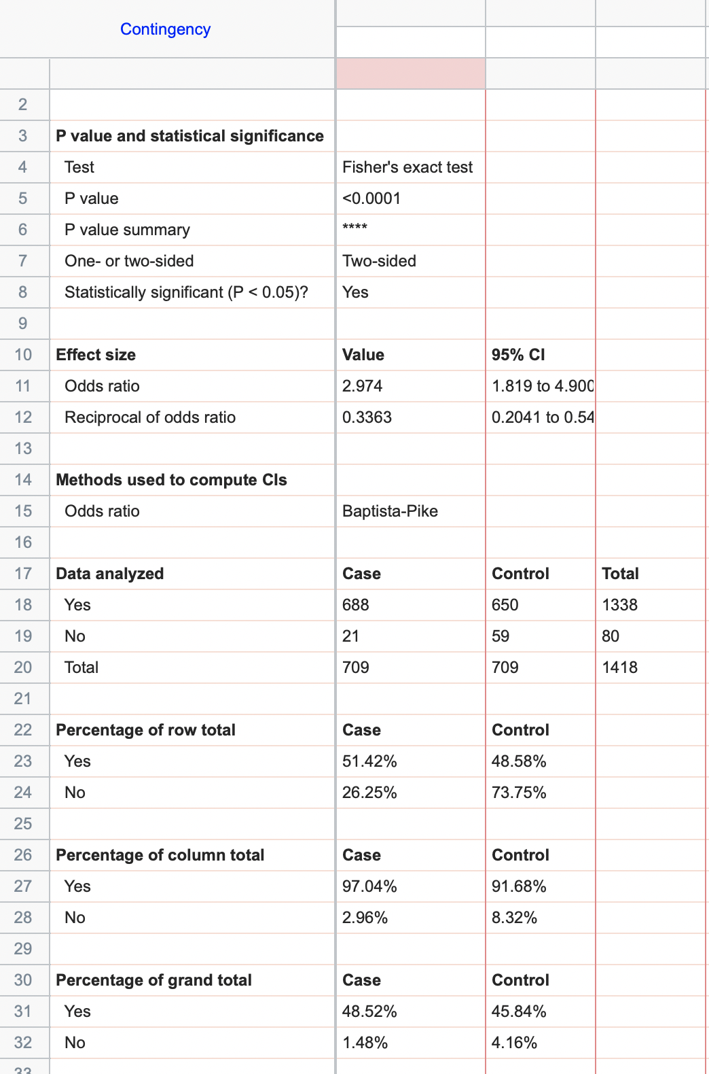

**4. Relative Risk**

4.1 Open a blank contingency sheet (see 1.1). **Copy data 3** from “Prism examples.xlsx”.



4.2 Click **Analyze,** select **Chi-square (and Fisher’s exact) test** under Contingency table analyses list, then click **OK.** Select **Relative risk.** Then **OK**.

4.3 Result return with 95% confidence interval.

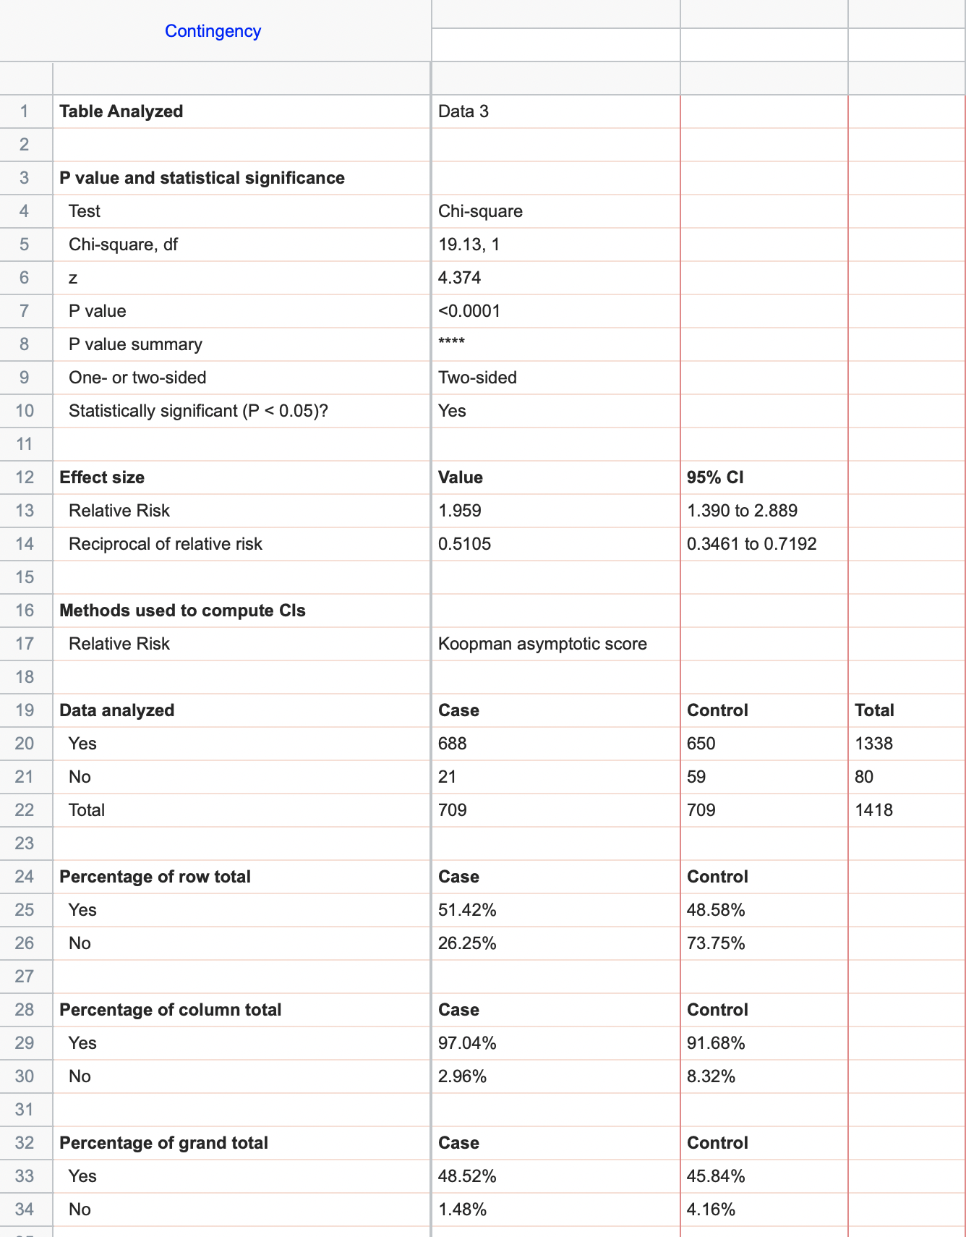

**5. 1 Pearson Chi-square test**

5.1.1 Select **Contingency** under “New Table & Graph”; Select **Enter or import data into a new table**, then click **Create**.

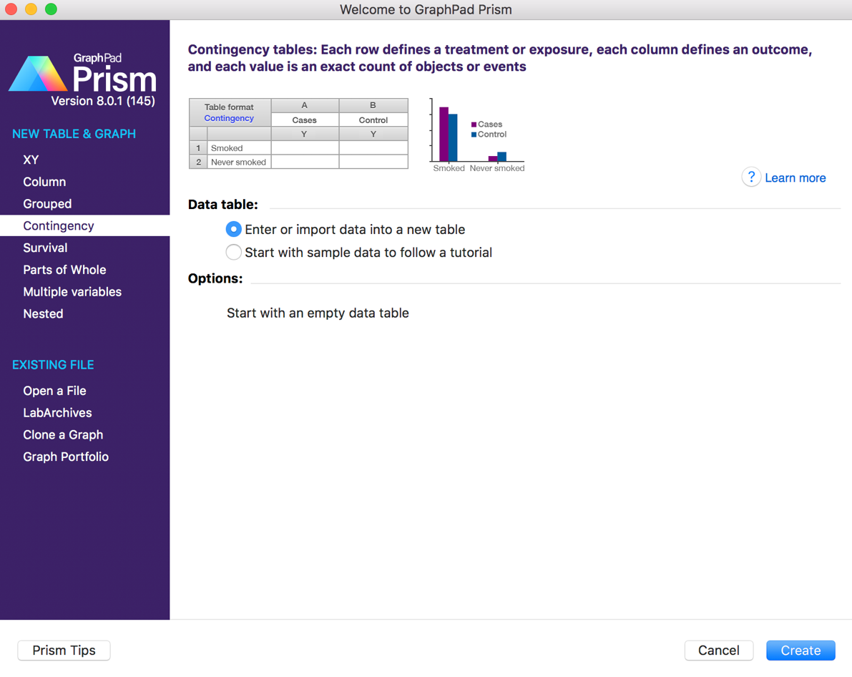

5.1.2 Open a blank contingency sheet (see 1.1). **Copy data 3** from “Prism examples.xlsx”.

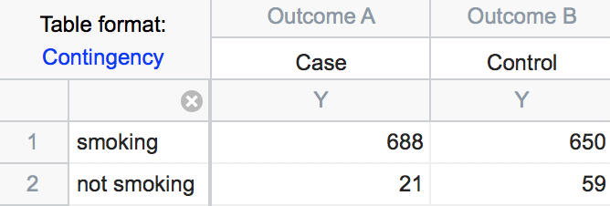

5.1.3 Click **Analyze ** then select **Chi-square (and Fisher’s exact) test** under Contingency table analyses list. Check the columns you want to analyze on the right side, then click **OK**.

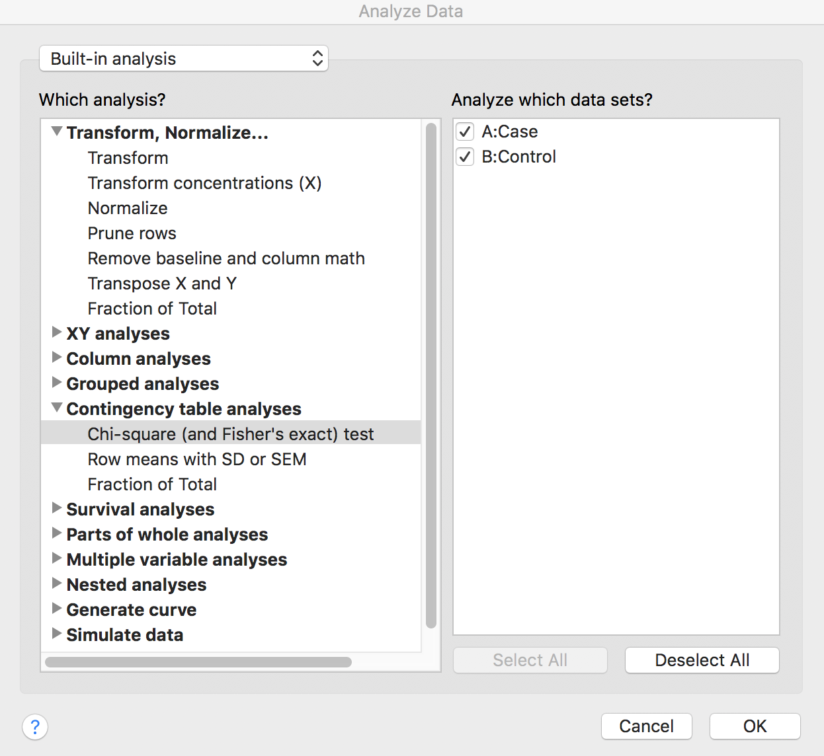

5.1.4 Select test type under Method to compute P value and other report statistic under Effect sizes to report. Click **Chi-square test**, then **OK**.

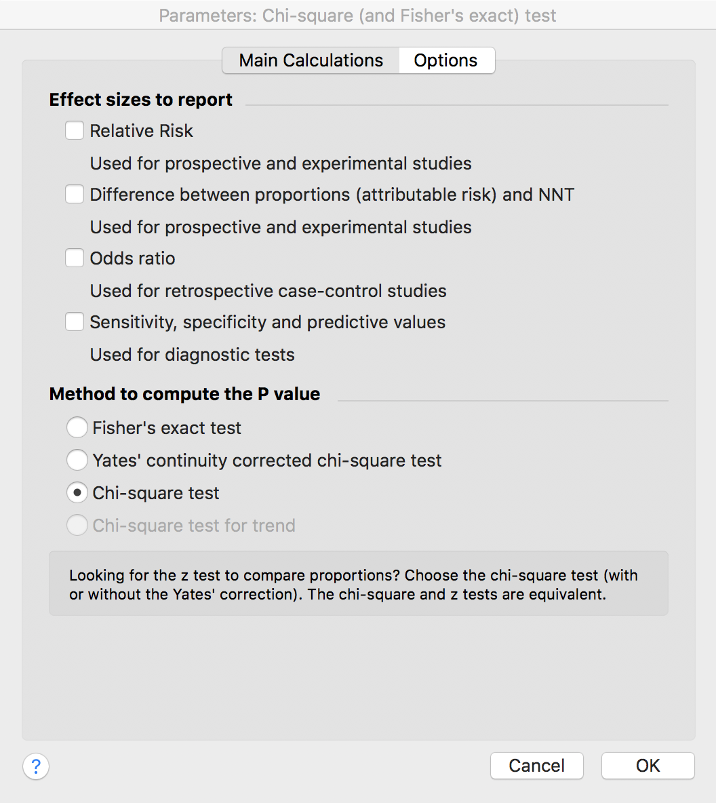

5.1.5 Result includes p-value, marginal table, and marginal percentage. Chi-square statistic, degree of freedom and p-value are circled. Test result is significant, which means reject the null hypothesis that smoking and lung cancer are independent.

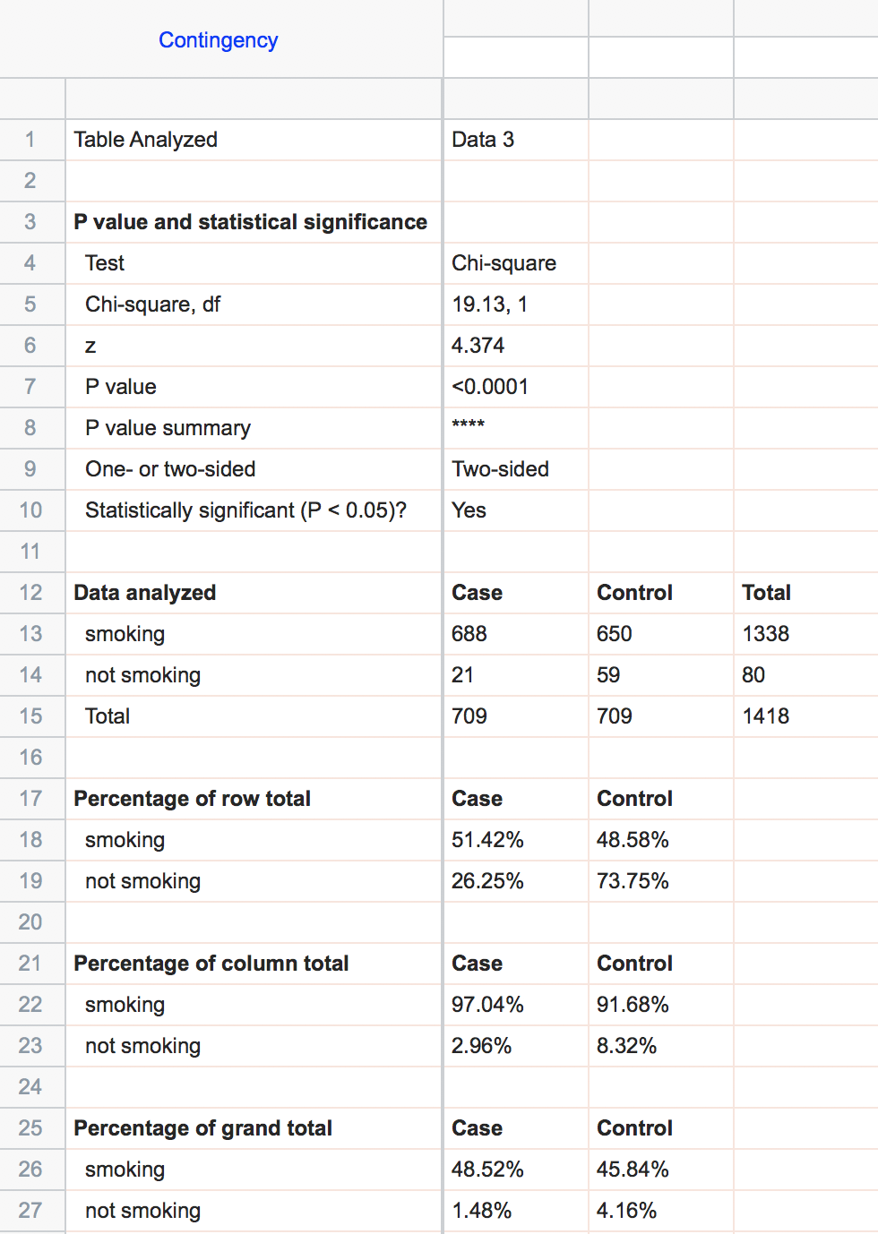

**5.2 Fisher’s exact test**

5.2.1 Follow 5.1.1 to open a blank data sheet. Copy **data 4 from “Prism examples.xlsx”.**

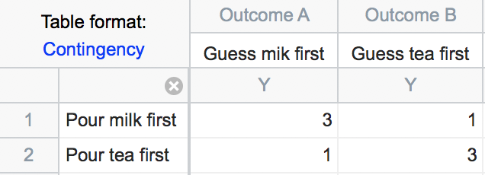

5.2.2 Select test type under Method to compute P value and other report statistic under Effect sizes to report. Click **Fisher’s exact test**, then go to **Options**, select **One-sided** under Calculations options, then click **OK**.

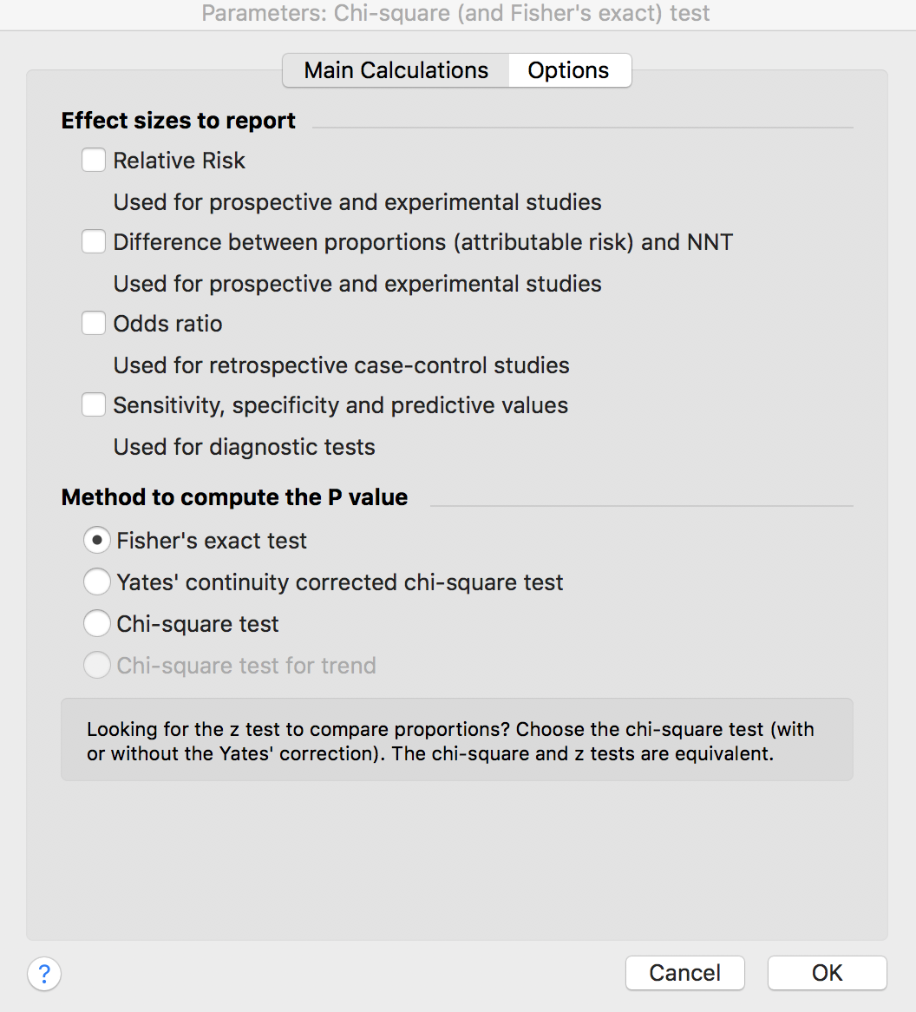

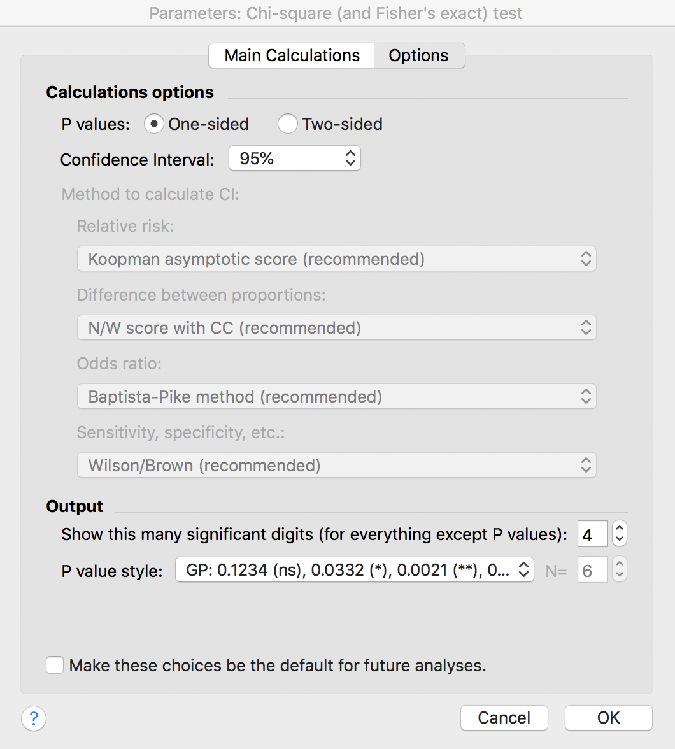

5.2.3 Review Result includes p-value, marginal table, and marginal percentage. p-value is circled. Test result is not significant, which means cannot reject the null hypothesis that pouring order and guessing order are independent.

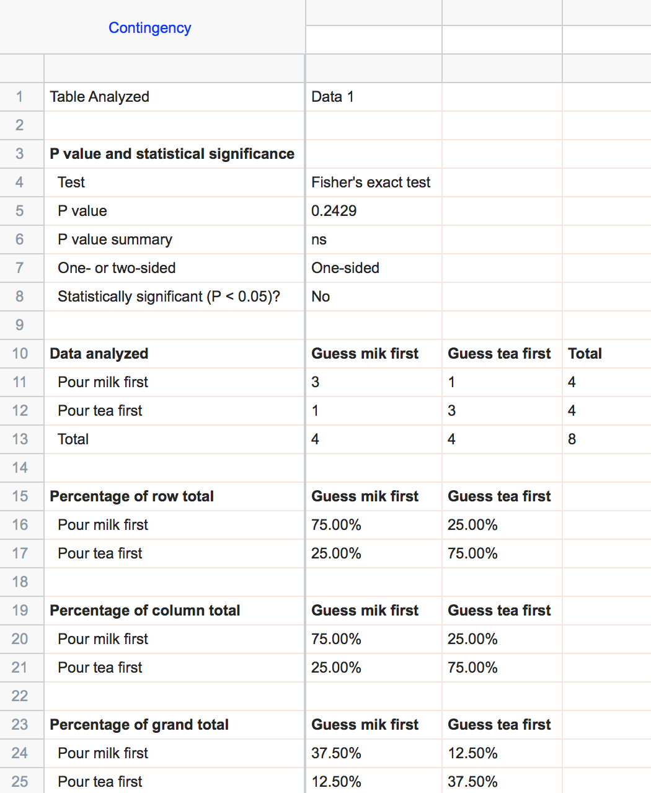

**5.3 McNemar test**

McNemar test is available via Prism web. (<https://www.graphpad.com/quickcalcs/>)

5.3.1 Click in the website above, select Categorical data, select **McNemar’s test to analyze a matched case-control study**, then click **Continue**.

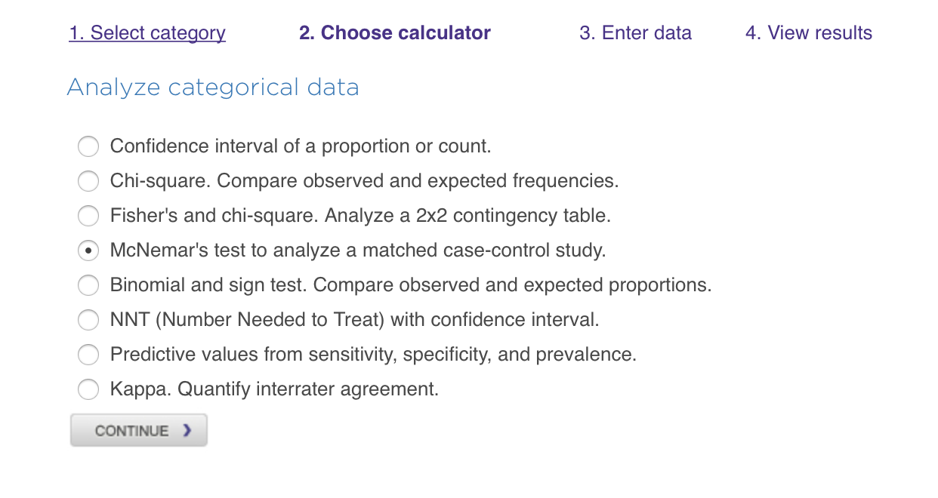

5.3.2 **Input # of pairs of case and control**. In our example, 2004 Election as case and 2008 Election as control (or they can be exchanged, result won’t change), then click **Calculate**.

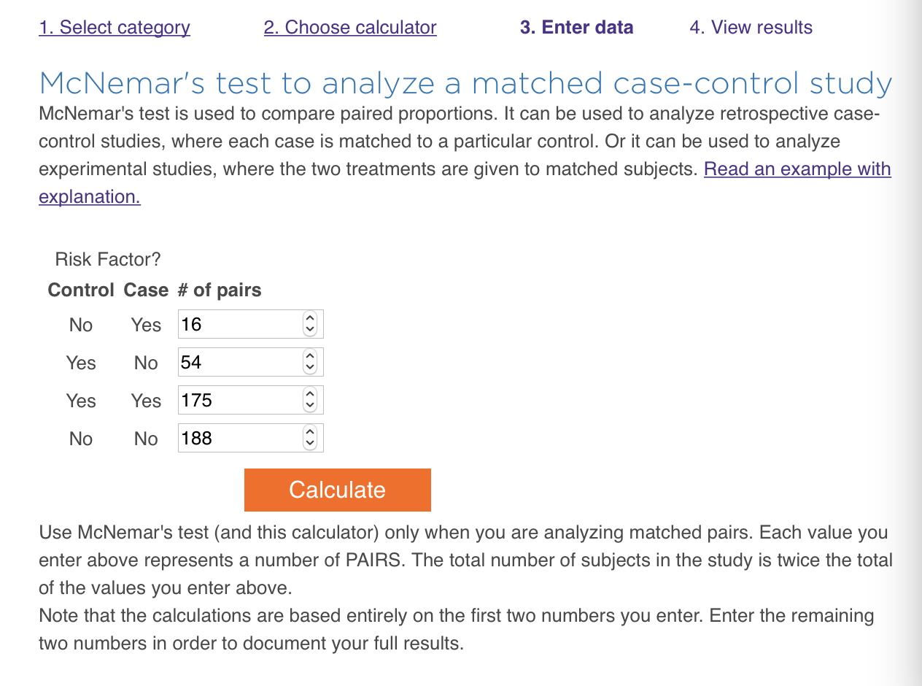

5.3.3 Results include summary, p-value, odds ratio and contingency table. The result is significant, we can reject the null hypothesis that 2004 and 2008 election are independent.

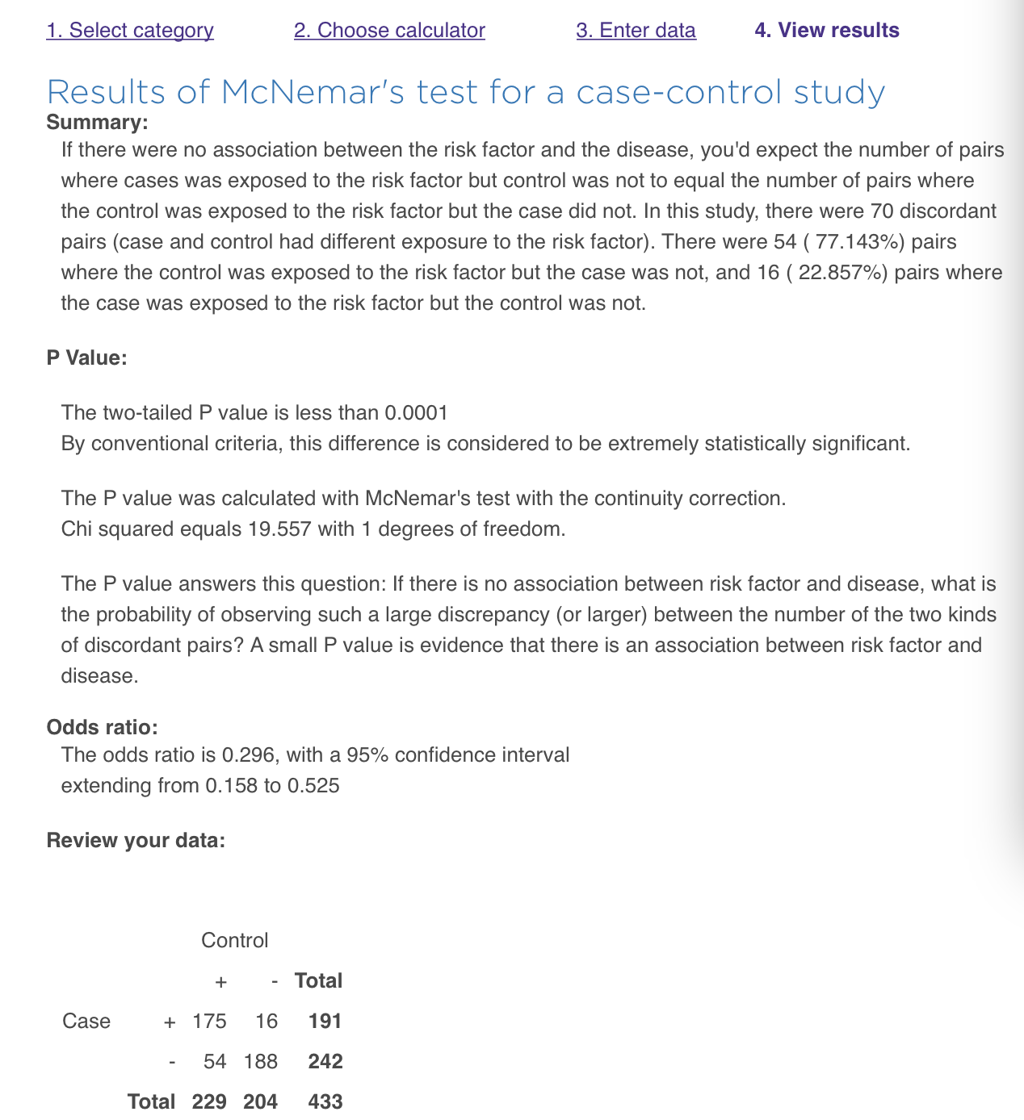

**5.4 Chi-square Test for Trend**

5.4.1 Follow 5.1.1 to open a blank data sheet. Copy **data 5 from “Prism examples.xlsx”.**

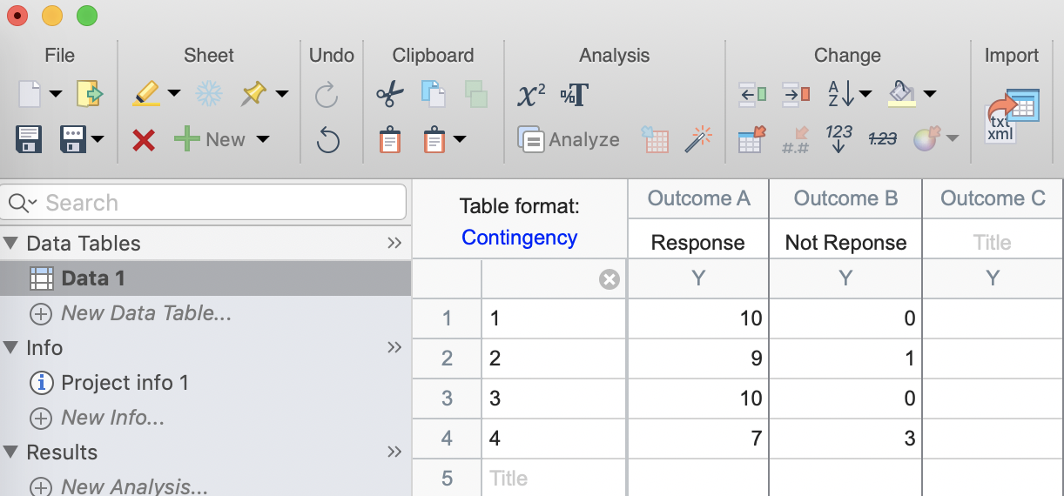

5.4.2 Click **Analyze ** then select **Chi-square (and Fisher’s exact) test** under Contingency table analyses list. Select **Chi-square for trend**. Click Options. Here only two-sided test is default. Then click **OK**.

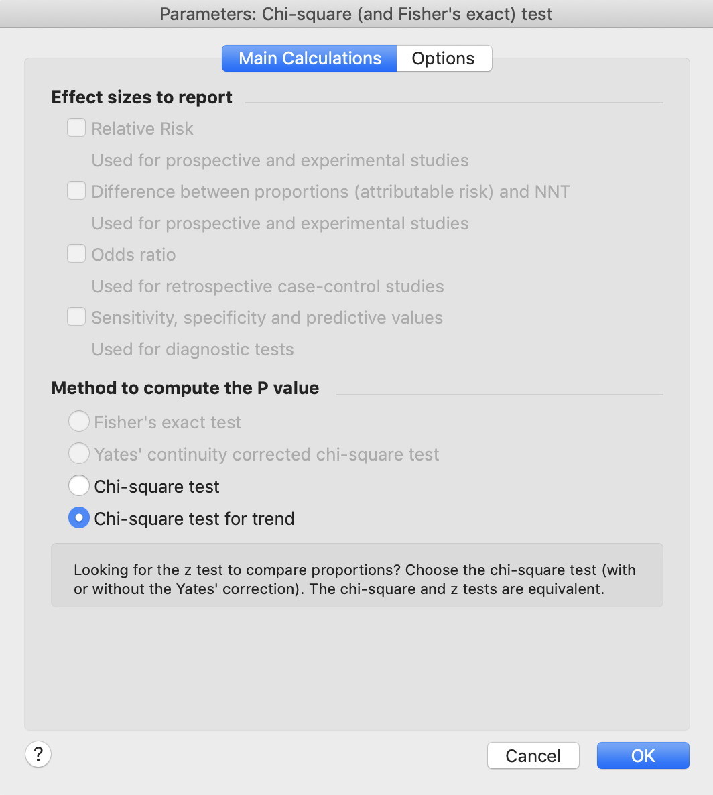

5.4.3 Review results. P-value is 0.0593. This is two-sided test. We cannot reject the null hypothesis of no linear trend between response across increasing dosage at significance level 0.05.

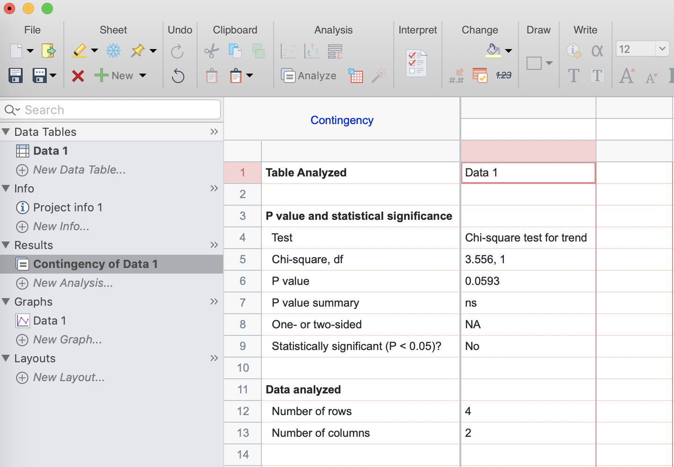

In the end, if you have any questions regarding to this topic, please contact me (jingwen.gu@nih.gov) or submit a request to BCBB (bioinformatics@niaid.nih.gov).